Report for the Northern Powerhouse Partnership on Adjusted Progress 8 (2018-2019)
George Leckie and Lucy Prior, Centre for Multilevel Modelling, University of Bristol
13th October 2020
About the research
- Progress 8 is the Department for Education’s (DfE) headline measure of the average academic progress pupils make in each school over secondary schooling. The measure adjusts pupil’s GCSE results for their end of primary schooling Key Stage 2 (KS2) test results.

- The DfE and Ofsted both rely heavily on Progress 8 to hold schools to account.

- The DfE argue that Progress 8 is a fair measure as it accounts for school intake attainment differences in pupils’ KS2 test scores. However, Progress 8 ignores school intake differences in all other pupil background characteristics, yet these also predict why some schools score higher at GCSE than others.

- The DfE’s decision to ignore pupil background when comparing schools is in stark contrast to both the academic literature and practitioner commentaries, both of which argue that such adjustments should be made when holding schools to account.

- This research compared the DfE’s 2019 Progress 8 measure with an ‘Adjusted Progress 8’ version which accounts for pupil age, gender, ethnicity, English as an additional language (EAL), special educational needs (SEN), free school meal status (FSM), and residential deprivation.

- The results show that schools’ Progress 8 scores, differences in average scores between regions and for different school types all change dramatically once adjustments are made for pupil background. This leads to very different interpretations and conclusions about both individual schools and educational differences.

Analysis
- The DfE Progress 8 scores are calculated as school averages of the residuals from a linear regression of pupil Attainment 8 on pupil KS2 scores where pupil KS2 scores are entered into the regression as a series of 34 dummy variables.

- Our Adjusted Progress 8 measure extends this methodology by adding further dummy variables for pupil age, gender, ethnicity, EAL, SEN, FSM and residential deprivation. In doing so, this more advanced measure statistically adjusts for existing national average differences in attainment by each of these pupil characteristics.

- For 2019, DfE modifies the Progress 8 scores of pupils with extreme negative values, replacing them with a minimum threshold value which is determined within each prior attainment group. We extend the approach to modify our Adjusted Progress 8 measure for extreme negative values.

Key findings
- Adjusting for pupil background would see the national league table rankings of a fifth of schools change by over 500 places.

- Adjusting for pupil background would lead 46% of schools judged ‘underperforming’ under Progress 8 to move up out of this banding.
- The high average Progress 8 score seen in London more than halves when we adjust for pupil background. This is principally due to these schools teaching high proportions of high progress ethnic groups. In contrast, the low average Progress 8 score seen in the North East improves substantially after adjustment due to the high proportions of poor pupils taught in this region.

- Other dramatic changes are seen for grammar schools and faith schools whose high average Progress 8 scores reduce substantially once the educationally advantaged nature of their pupils is considered. In contrast, the low average pupil progress seen in sponsored academies improves once the disadvantaged nature of their pupils is recognised.

- Progress 8 effectively punished schools teaching high proportions of disadvantaged pupils for the national underperformance of these groups.

- Progress 8 can therefore be argued to give too much emphasis to schools, rather than Government or society, as primarily responsible for the national underperformance of these groups. In contrast, adjusted versions of Progress 8 can be viewed as rebalancing the responsibility more on society and Government, rather than schools.

Policy recommendations
- The many well-known statistical issues with all attempts to measure school performance, not to mention more general concerns with perverse incentives and gaming behaviours introduced by high-stakes testing, suggest the DfE and Ofsted should place far less emphasis on Progress 8 when holding schools to account.

- Given the importance of pupil background in driving schools’ scores, the Government should revise their current school league tables to include an adjusted Progress 8 measure side-by-side with Progress 8 to present a more informative picture of school performance.

- In this case, the DfE should provide users with greater insight as to why schools achieve the scores they do, accompanied with more detailed explanation as to the limitations of using such scores for school accountability, especially emphasising the statistical uncertainty associated with all school rankings.

Further information
A version of this research based on results from 2016 is available as a journal article in the British Educational Research Journal.
https://onlinelibrary.wiley.com/doi/10.1002/berj.3511
A video recording of a presentation of the 2016 work is available.
https://mediacentral.ucl.ac.uk/Play/15633
The slides are also available, as is a working paper version of the 2016 work.
http://www.bristol.ac.uk/cmm/media/leckie/leckie2018-11-14-london.pdf

Acknowledgements
This work was produced using statistical data from ONS. The use of the ONS statistical data in this work does not imply the endorsement of the ONS in relation to the interpretation or analysis of the statistical data. This work uses research datasets which may not exactly reproduce ONS aggregates.

Appendix: Detailed findings
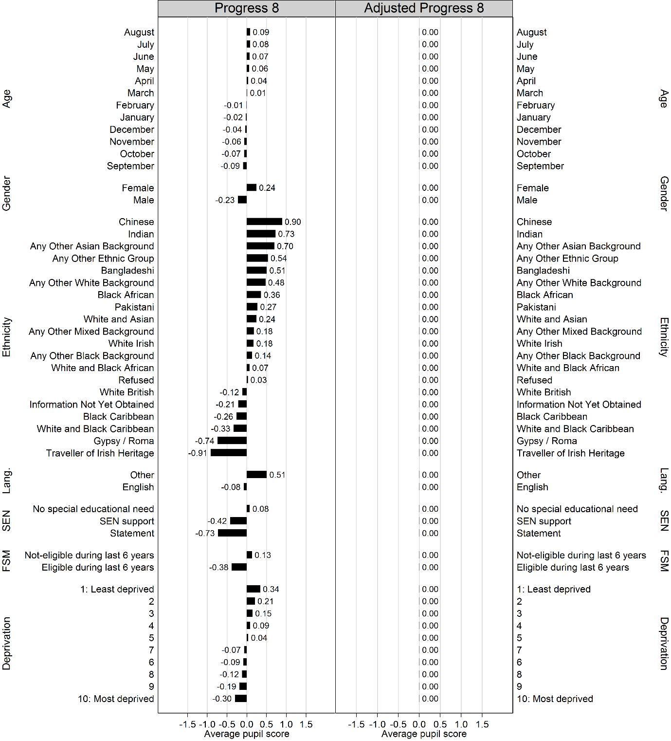
Figure 1. Average pupil Progress 8 and Adjusted Progress 8 scores by pupil characteristics.
- The left-hand plot is for Progress 8. The plot shows how much better, on average, each pupil group performs than predicted by the KS2 scores. The results are expressed in terms of grades per GCSE subject.

- The right-hand plot is for Adjusted Progress 8. The plot shows how much better, on average, each pupil group performs than predicted when these predictions are based on combining information on their KS2 scores, age, gender, ethnicity, language, SEN, FSM and deprivation. The results are expressed in terms of grades per GCSE subject. By definition, there is no variation in average Adjusted Progress 8 by pupil characteristics as these have all been accounted for in the construction of this more complex measure.

- August born pupils make 0.18 grades more progress per subject than their September born peers. Given that the standard deviation (SD) in Pupil Progress 8 is 1.28, this difference is reasonably substantial, approaching one seventh of 1.00 SD. More generally, younger pupils within the academic year make more progress than older pupils. However, younger pupils score lower than older pupils at the end of primary schooling and they still do so at the end of secondary schooling despite their higher progress. Thus, the higher progress shown among younger pupils reflects their attainment approaching, but not reaching, the higher attainment of their older peers during secondary schooling.

- Girls make 0.47 grades more progress per subject than boys. The cohort of girls completing KS4 in 2019 scored similarly to boys at the end of primary schooling and so the gender attainment gap widened over secondary schooling.

- There is substantial variation in Progress 8 by ethnic group. Chinese pupils (0.3% of all pupils) score, on average, 0.90 grades higher per subject than expected given their prior attainment, Indian pupils (2.7%) 0.73 grades higher, Bangladeshi pupils (1.8%) 0.51 grades higher, and Black African pupils (3.3%) 0.36 grades higher. In contrast, White British pupils (72%), on average, score 0.12 grades lower than expected. Black Caribbean pupils (1.4%) do worse still, scoring 0.26 grades lower than expected. However, Gypsy/Roma pupils (0.2%) and Travellers of Irish Heritage (0.02%) show the lowest progress, scoring 0.74 and 0.91 grades lower.

- Pupils speaking English as an additional language (14% of all pupils) make 0.59 grades more progress per subject than pupils who speak English as their first language. Essentially, this pupil group catches up and by the end of secondary schooling overtakes their peers who speak English as a first language.

- Pupils with SEN support (13% of all pupils), especially those with statements or education, health and care (EHC) plans (2.1%), make considerably less progress than pupils with no special educational needs. These two pupil groups already score lower at the end of primary schooling and so these attainment gaps widen during secondary schooling.

- Pupils eligible for FSM (24.5% of all pupils) make 0.51 grades less progress per subject than pupils who were not eligible for FSM during the previous 6 years.

- Pupils residing in disadvantaged neighbourhoods also make less progress than those in more prosperous neighbourhoods. For example, pupils living in the most affluent 10% of neighbourhoods score, on average, 0.34 grades higher per subject than predicted by their prior attainment, while pupils living in the poorest 10% of neighbourhoods score 0.30 grades lower per subject than predicted. This social gradient is already present at the end of primary schooling and so widens over secondary schooling.

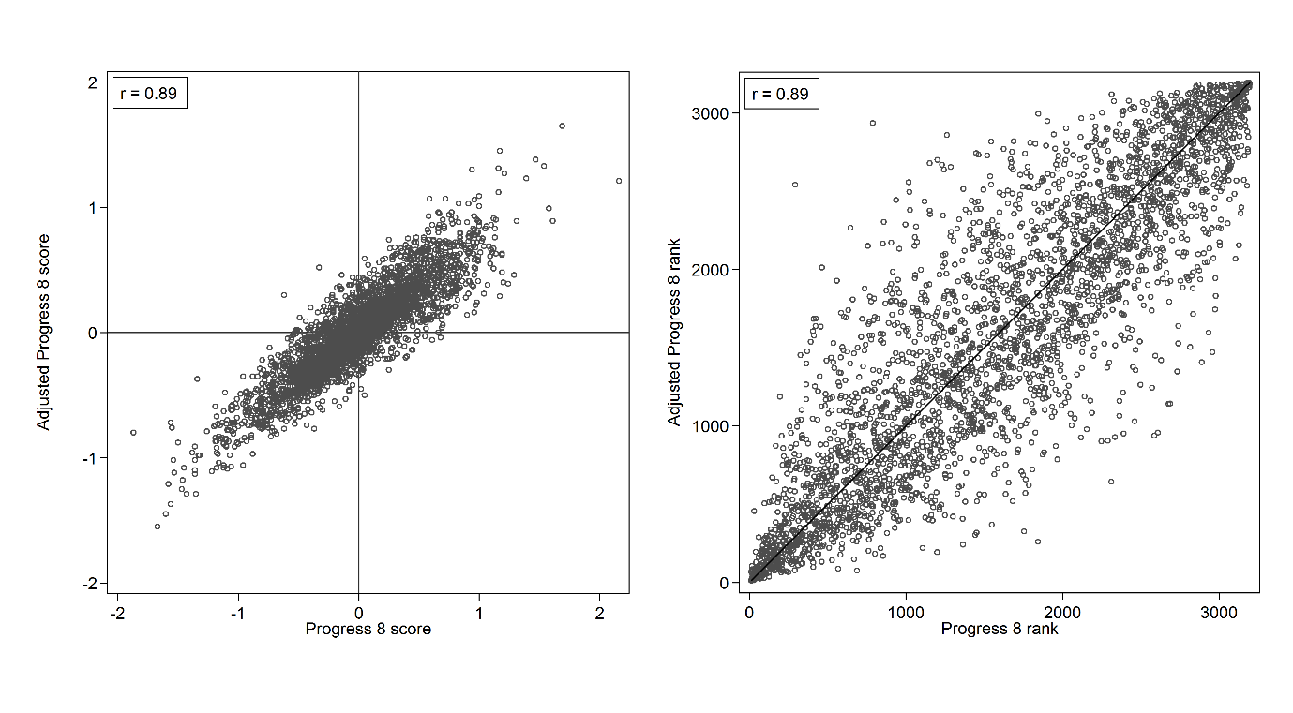
Figure 2. Scatterplots of school average Progress 8, and Adjusted Progress 8 scores and ranks
- The left-hand plot presents Adjusted Progress 8 scores against Progress 8 scores. The right-hand plot presents Adjusted Progress 8 ranks against Progress 8 ranks.

- The Adjusted Progress 8 against the Progress 8 scatterplots show the strong associations (r(Pearson) = 0.89; r(Spearmen) = 0.89). However, school performance nonetheless differs greatly depending by which progress measure schools are judged. This is shown by the substantial number of schools located away from the 45-degree line in the right-hand plot.

- Indeed, changing from Progress 8 to Adjusted Progress 8 would lead 681 schools (21.4% of all schools in the country) to move up or down the national league table by 500 or more ranks with 125 schools (3.9%) moving over 1,000 ranks. Bearing in mind that there are only around 3,000 secondary schools nationally, these changes are very large indeed.

- The rows of the table are the five bandings of Progress 8. The columns are the five bandings of adjusted Progress 8. The percentages in each row sum to 100%. They show the percentage of schools in each Progress 8 banding who would move to a different banding under Adjusted Progress 8.
Table 1. Cross-tabulation of school Progress 8 bandings by school Adjusted Progress 8 bandings.
 | Adjusted Progress 8 banding
Progress 8 banding | Well below | Below | Average | Above | Well above | Total
Well above average | 0 | 0 | 45 | 170 | 232 | 447
 | 0.0% | 0.0% | 10.1% | 38.0% | 51.9% | 100%
Above average | 0 | 7 | 165 | 293 | 63 | 528
 | 0.0% | 1.3% | 31.3% | 55.5% | 11.9% | 100%
Average | 3 | 141 | 855 | 164 | 7 | 1,170
 | 0.3% | 12.1% | 73.1% | 14.0% | 0.6% | 100%
Below average | 20 | 367 | 226 | 6 | 0 | 619
 | 3.2% | 59.3% | 36.5% | 1.0% | 0.0% | 100%
Well below average | 235 | 164 | 32 | 1 | 0 | 432
 | 54.4% | 38.0% | 7.4% | 0.2% | 0.0% | 100%
Total | 258 | 679 | 1,323 | 634 | 302 | 3,196
 | 8.1% | 21.3% | 41.4% | 19.8% | 9.5% | 100%

- The table shows that moving from Progress 8 to Adjusted Progress 8 would lead 1,184 schools (38% of all schools) to change bandings.

- Importantly, the number of schools assigned to the ‘well below average’ banding would drop from 432 schools (13.5% of all schools) to 258 schools (8.1% of all schools), a decrease of 174 schools, or almost a half.

- At the other extreme, the number of schools assigned to the ‘well above average’ banding would decrease from 447 schools (14% of all schools) to 302 schools (9.5% of all schools), a decrease of 145 schools, or almost a third.

- Essentially, the Adjusted Progress 8 model is a better predictive model of pupil Attainment 8 scores than the Progress 8 model. As a result, both pupil and school progress scores vary less than when the Progress 8 model is used. In turn, fewer schools appear in the most extreme bandings than when the Progress 8 model is used.

- The left-hand plot is for Progress 8. The plot shows how much better, on average, each school group performs than predicted by their KS2 scores. The results are expressed in terms of grades per subject.

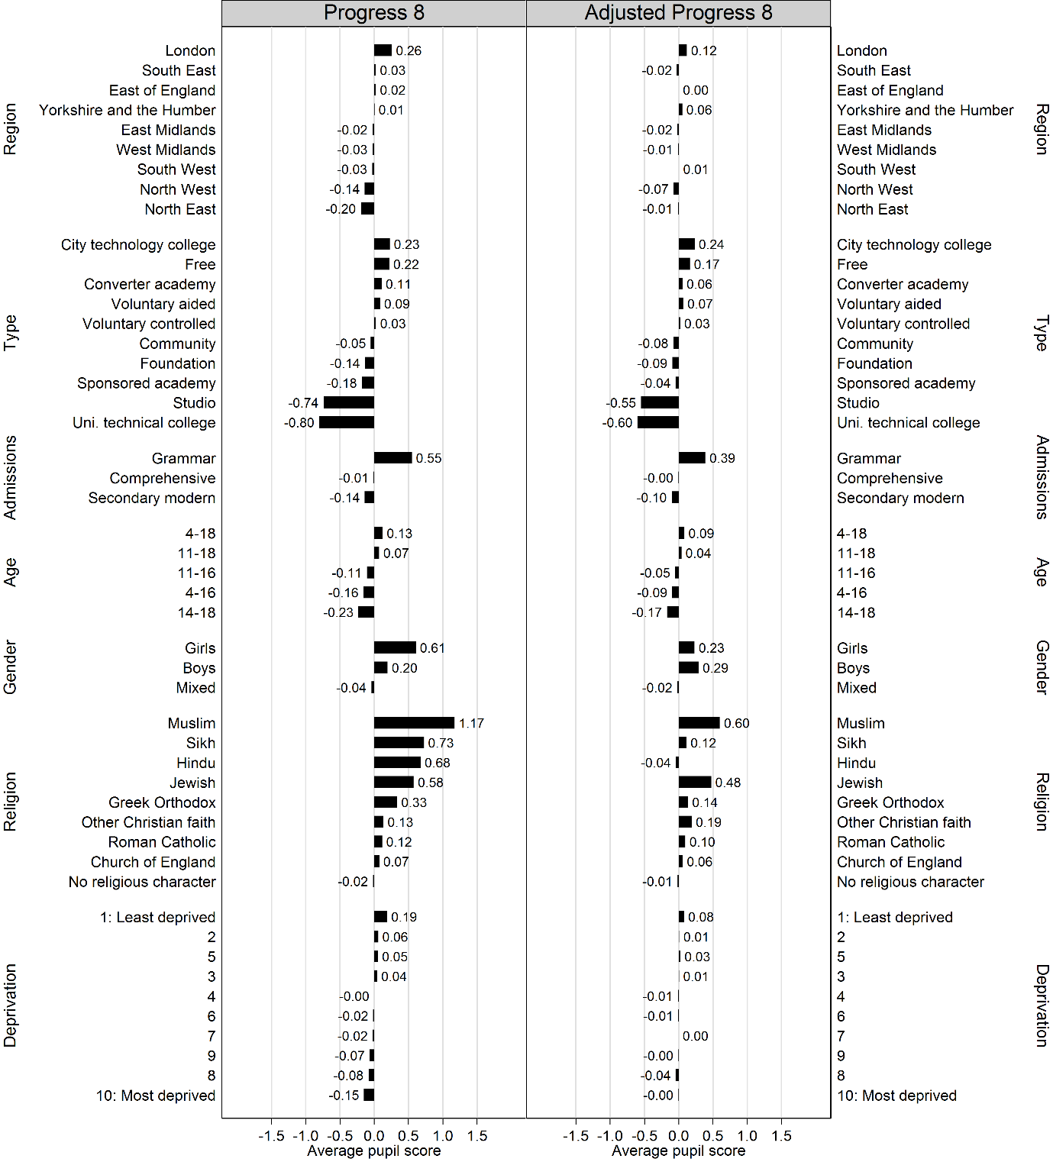
- The right-hand plot is for Adjusted Progress 8. The plot shows how much better, on average, each school group performs than predicted by their KS2 scores, age, gender, ethnicity, language, SEN, FSM, and deprivation. The results are expressed in terms of grades per GCSE subject.

Figure 3. Average pupil Progress 8 and Adjusted Progress 8 scores by school characteristics.

- According to Progress 8 (left-hand panel), pupils in London schools (465 schools; 14.6% of all schools) make, on average, the most progress, scoring 0.26 grades higher per subject than pupils nationally with the same prior attainment. However, under Adjusted Progress 8 (right-hand panel) this ‘London effect’ halves to just 0.12 grades per subject.

- Further analysis suggests that while London schools are somewhat disadvantaged by teaching relatively poor intakes (they have relatively high rates of FSM pupils and pupils in deprived neighbourhoods), they are to a much greater extent advantaged by teaching particular ethnic groups who nationally tend to make high progress (in particular, Black Africans, Any Other Ethnic Group, Any Other White Background, Bangladeshi, and Indian). They also teach high proportions of pupils who speak English as an additional language, another high progress pupil group.

- Now consider school in the North East (153 schools: 4.8%), the region which shows the lowest average pupil progress according to Progress 8, with a score of -0.20. Under Adjusted Progress 8, this score increases to -0.01. Essentially, under Progress 8, schools in the North East are doubly disadvantaged by teaching not just relatively poor intakes, but by also disproportionately teaching White British pupils. Both of these pupil characteristics are associated with below average progress (Figure 1).

- Average pupil progress for many school types remains approximately the same when we move from Progress 8 to Adjusted Progress 8. However, for some school types, average pupil progress changes markedly. In particular, among converter academies (1,479 schools; 46.3% of all schools), average pupil progress drops from 0.11 to 0.06, while among sponsored academies (691; 21.6%), average pupil progress increases from -0.18 to -0.04. Here the driving factor for the reduction in the apparent difference in performance is that converter academies teach a much lower percentage of poor pupils (18.9% eligible for FSM) than sponsored academies (36.8% eligible for FSM).

- Similarly, the very low average pupil progress seen in both university technical colleges (46 schools: 1.4%) and studio schools (26 schools: 0.8%) is substantially reduced once the types of pupils who tend to attend these schools is taken into account. These schools are disadvantaged by teaching a relatively high percentage of SEN pupils and boys.

- In terms of school admissions, according to Progress 8, pupils in grammar schools score, on average, a considerable 0.55 grades higher per subject than pupils nationally with the same prior attainment. However, under Adjusted Progress 8, the apparent benefit of attending a grammar school is reduced by over a quarter: average pupil progress drops from 0.55 to 0.39. Grammar schools are especially advantaged by the low percentage of poor (6.4%) and to a lesser extent SEN pupils (6%) they teach, but are also advantaged by disproportionately teaching various high progress ethnic groups.

- While nearly all schools in England are mixed-sex, there are a small number of all-girls schools (206 schools; 6.5% of all schools) and all-boys schools (150 schools; 4.7%). Progress 8 suggests pupils in single-sex schools, especially all-girls schools, make more progress than pupils in mixed-sex schools. However, average pupil progress in all-girls schools drops from 0.61 to 0.23 when we move from Progress 8 to Adjusted Progress 8. In contrast, the average pupil progress in all-boys schools increases from 0.20 to 0.29 and so the performance of all-boys schools now appears more impressive than that of all-girls schools. The reason for this change is that Adjusted Progress 8 adjusts for pupil gender whereas Progress 8 does not. Nationally, girls outperform boys (Figure 1). Thus, whereas Progress 8 compares girls in all-girls schools to girls and boys nationally, Adjusted Progress 8 only compares girls in all-girls schools to girls nationally. We note that single-sex schools are disproportionately grammar schools whose higher average pupil progress we have already reported.

- Progress 8 shows pupils in religious schools typically make more progress than those in schools with no religious character. Especially high progress in seen in the small number of Muslim (14 schools), Jewish (13 schools), Sikh (3 schools), Hindu (1 school) and Greek Orthodox (1 school) schools. However, the results for these schools change markedly when we turn to Adjusted Progress 8. In terms of Muslim schools, average pupil progress halves from 1.17 under Progress 8 to 0.60. The intuition for this drop is that these schools teach very high percentages of Indian (38.6%) and Pakistani (37.5%) pupils, as well as those don’t speak English as a first language (81.7%). These characteristics are nationally associated with making high progress (Figure 1).

- An even more extreme change is shown by the single Hindu school where average pupil progress changes from 0.68 under Progress 8 to -0.04 under Adjusted Progress 8. The large change seen here reflects that this school almost exclusively teaches Indian pupils (89.5%), one of the very highest progress ethnic groups.

- The average pupil progress for Jewish schools, on the other hand, changes relatively little. Here an analysis of the underlying data shows that accounting for ethnicity actually raises average pupil progress slightly as Jewish pupils fall under the White British ethnic group which nationally underperforms. However, Jewish schools also teach relatively prosperous intakes and so the net effect is that their average pupil progress is nonetheless lowered when one also additionally accounts for FSM and deprivation.

